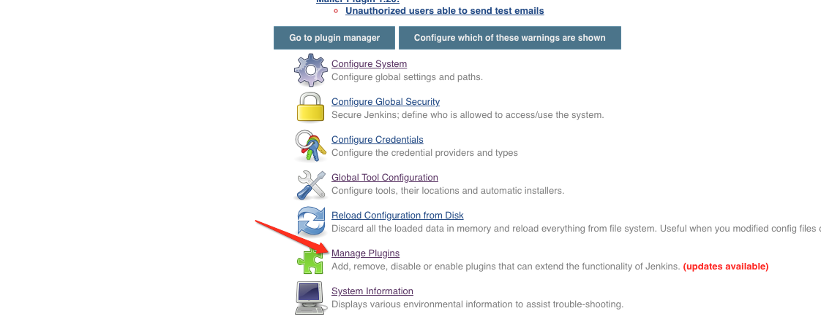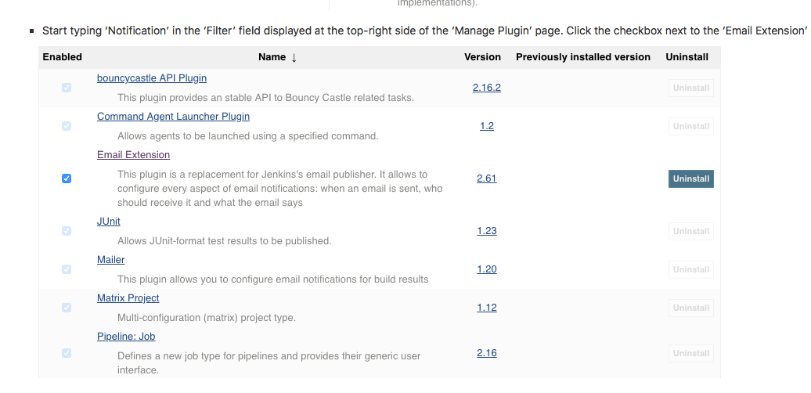

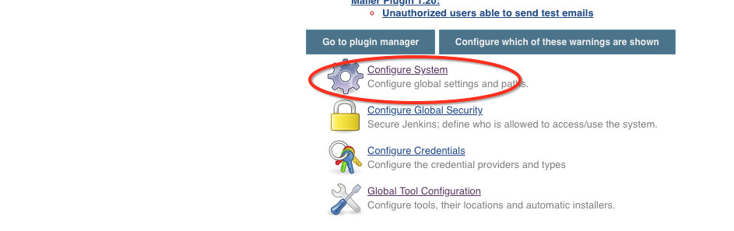

* Enter the SMTP server name under ‘Email Notification’. Click the ‘Advanced’ button and then click the checkbox next to the ‘Use SMTP Authentication’ option. Now, set the following fields.
  + **SMTP server name** : [smtp.gmail.com](http://smtp.gmail.com/)
  + **User name**: basel.automation.team@gmail.com
  + **Password**: Axon@vibe
  + **Use SSL** : Checked
  + **SMTP Port**: 456



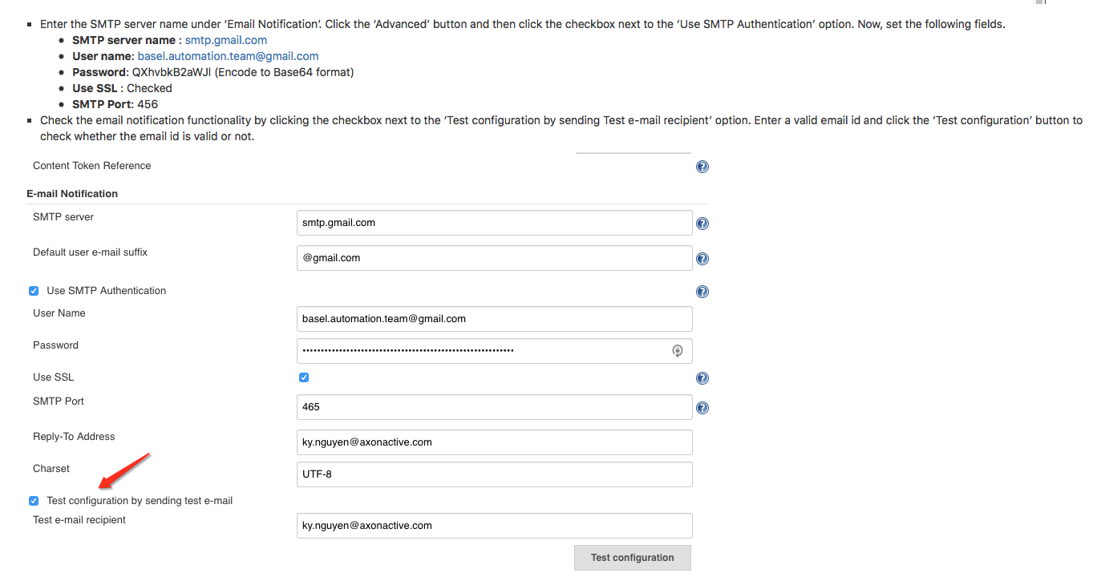

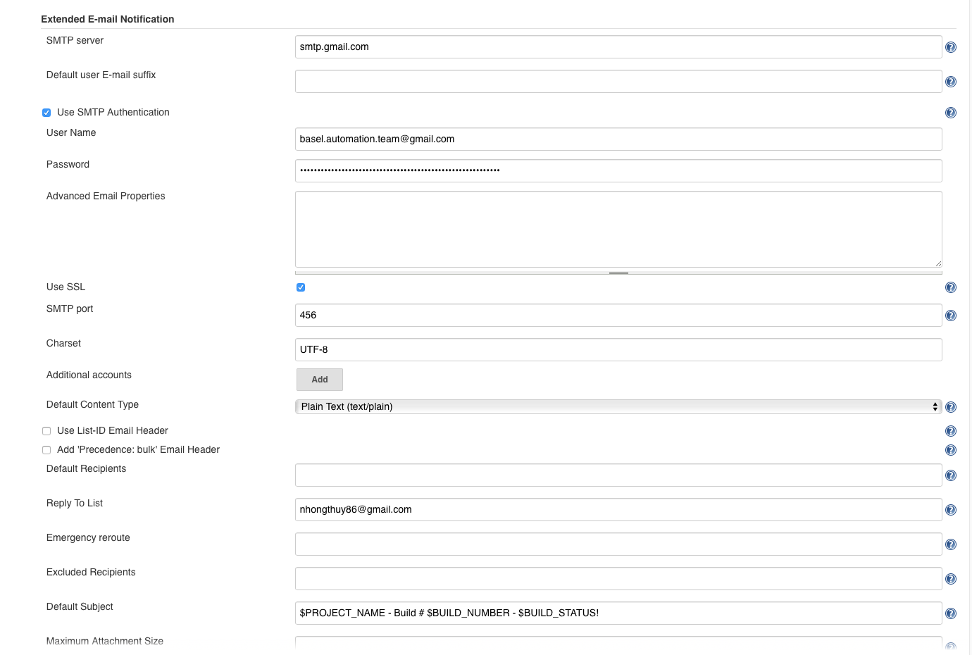

username/password is your email/password

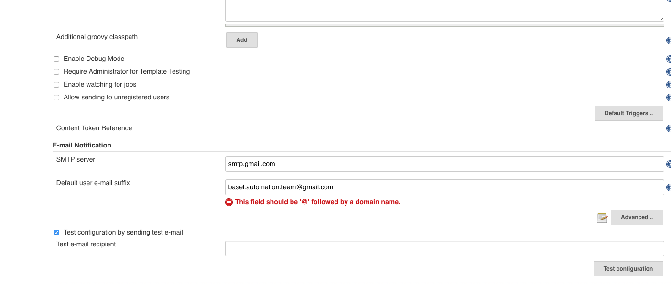

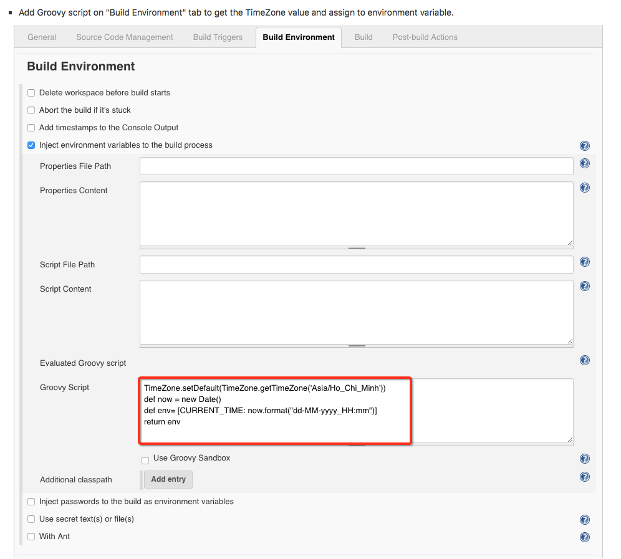

TimeZone.setDefault(TimeZone.getTimeZone(‘Asia/Ho_Chi_Minh’))

def now = new Date()

def env=[CURRENT_TIME: now.format(“dd-MM-yyyy_HH:mm”)]

return env

